|  |  |
| --- | --- |
| **NAME** | SABARI S |
|  |  |
| **REGISTER NUMBER** | 812620243018 |
|  |  |
| **NM ID** | 860EA13909FA6DAB93445590D3FC2710 |
|  |  |
|  |  |
|  | **ASSIGNMENT - 4** |
|  |  |

**Task - 1** **Create two lists and join those two lists**

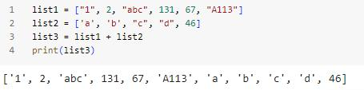

**Task - 2** **With IF statement find the even numbers**

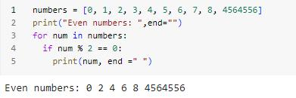

**Task - 3** **Create a dictionary with 3 keys and 2 values for each key**

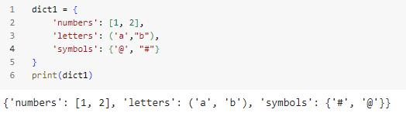

**Task - 4** **Create a function with IF statement which is used to find the odd numbers**

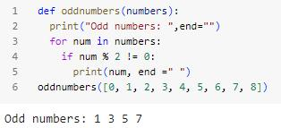

**Task - 5** **Write a Python function to sum all the numbers in a list.**

**Sample List : (8, 2, 3, 0, 7) Expected Output : 20**

